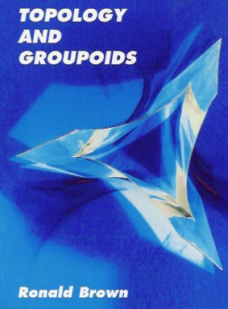
ISBN: 1-4196-2722-8; Library of Congress Control Number: 2006901092
Printed and Distributed by Booksurge LLC, S. Carolina, March 2006.
xxv+512 pages, perfect bound, 6” x 9”.
Price: US$31.99.

This is a retitled, revised, updated and extended edition of a topology text, previously published in 1968 and 1988. Its first half gives a geometric account of general topology appropriate to a beginning course in algebraic topology. It includes identification spaces, adjunction spaces and finite cell complexes, and a convenient category of spaces. The second half introduces the algebra of groupoids and shows the utility of this algebra for modelling geometry. It emphasises the importance of universal properties for allowing analogies between different mathematical structures.

Here are some examples of topics not available in other texts at this level: the initial topology on joins of spaces; the convenient category of k-spaces in the non Hausdorff case; a gluing theorem for homotopy equivalences; the Phragmen-Brouwer property, proved using the groupoid van Kampen theorem, and applied to the Jordan Curve theorem; the exact sequences of a fibration of groupoids; the equivalence between covering maps of spaces and covering morphisms of groupoids; the fundamental groupoid of an orbit space by a discontinuous action of a group as the orbit groupoid of the fundamental groupoid. (This is the only published account of this area.)

The book thus contains in essence an introduction to `combinatorial groupoid theory’ with applications to topology and group theory.

There are over 500 exercises, 114 figures, numerous diagrams.

Order direct from amazon .

An e-version, with full hyperref and some colour, is available for £5 from the author. Hyperref can be useful for study.
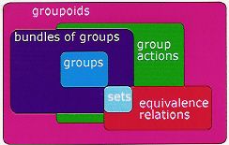
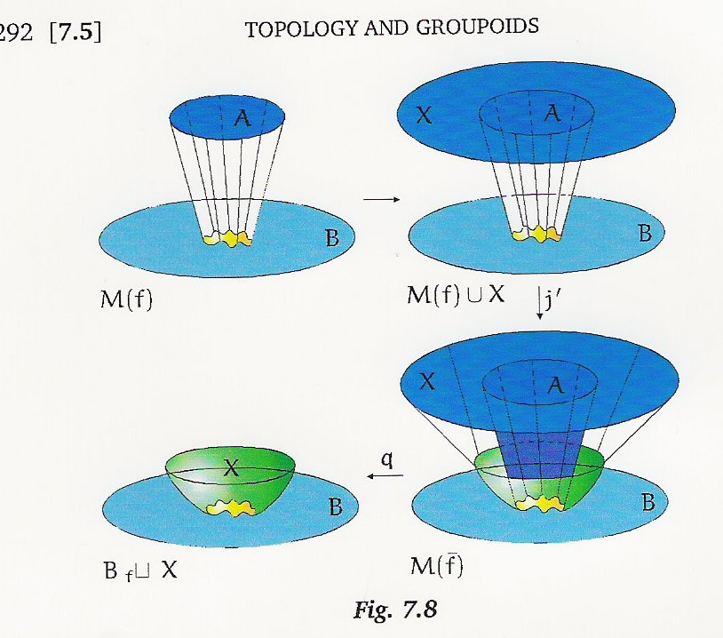

For more information, including reviews, see www.groupoids.org.uk/topgpds.html

